# **CS 255 System Design Document Template**

**This template lays out all the different sections that you need to complete for Project** **Two. Each section has guidance to prompt your thinking. You will need to continually** **reference the interview transcript as you work to make sure that you are addressing** **your client’s needs. There is no required length for the final document. Instead the goal** **is to complete each section based on what your client’s needs are. Remove this note** **when you are finished, and replace all bracketed text with the relevant information.**

## **UML Diagrams**

### **UML Use Case Diagram**

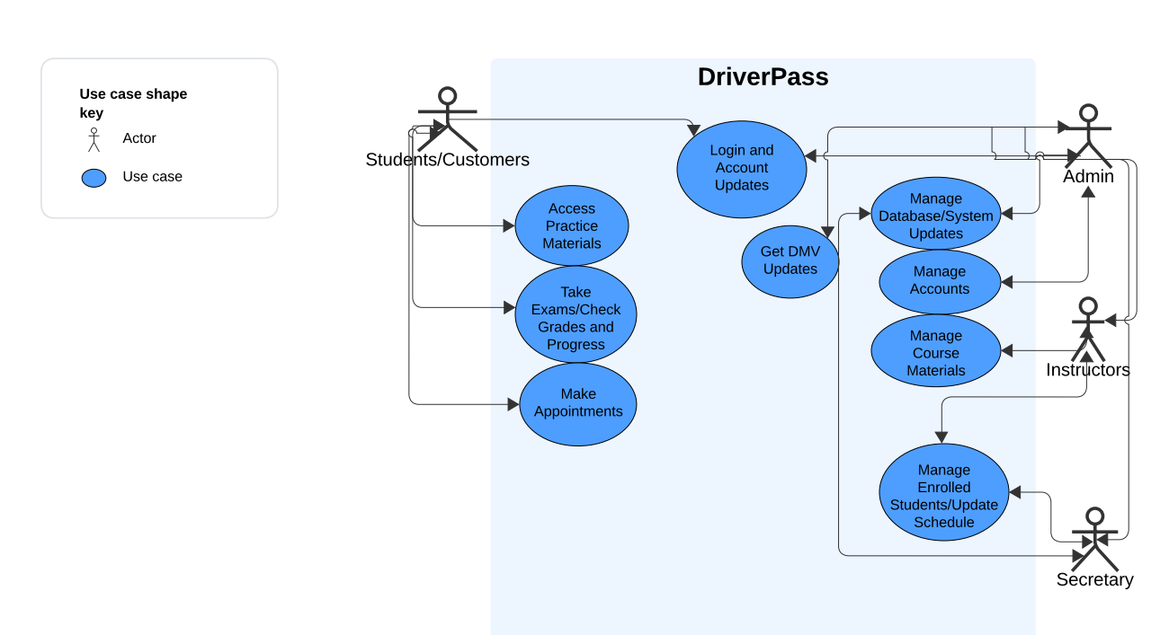

### **UML Activity Diagrams**

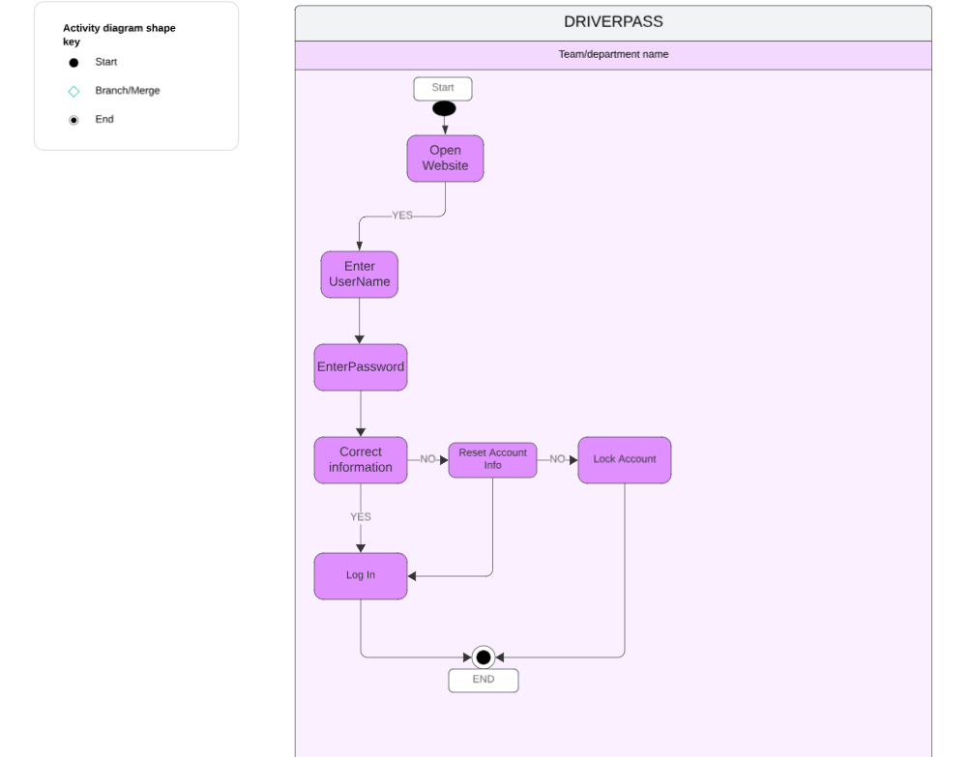

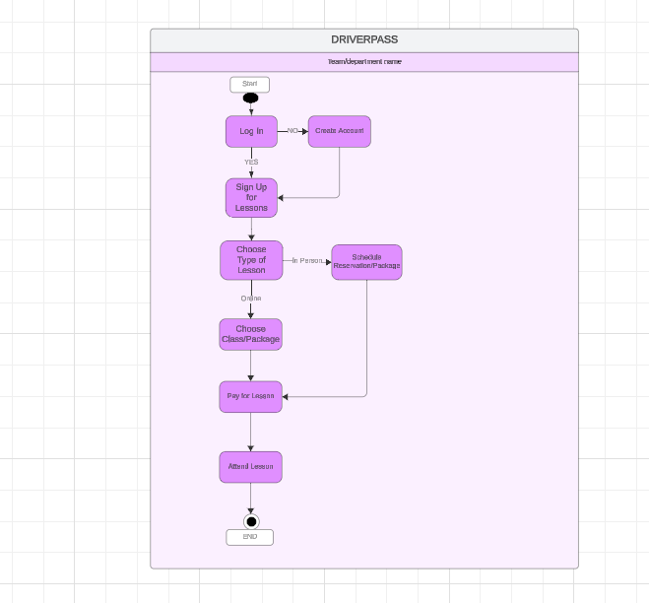

### **UML Sequence Diagram**

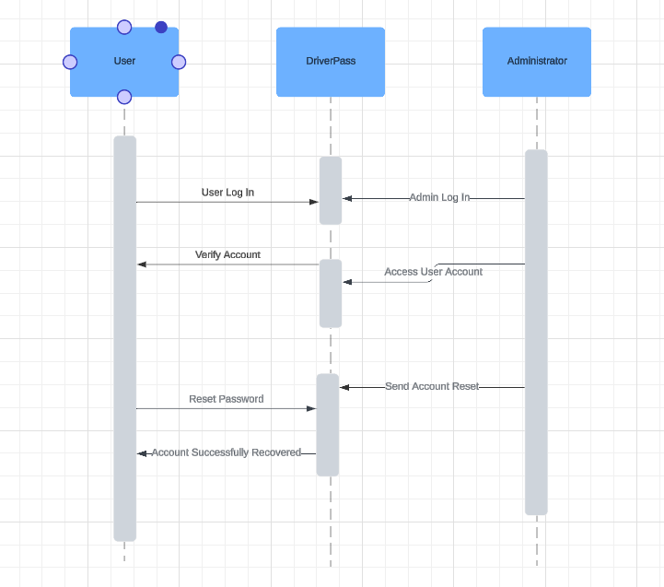

### **UML Class Diagram**

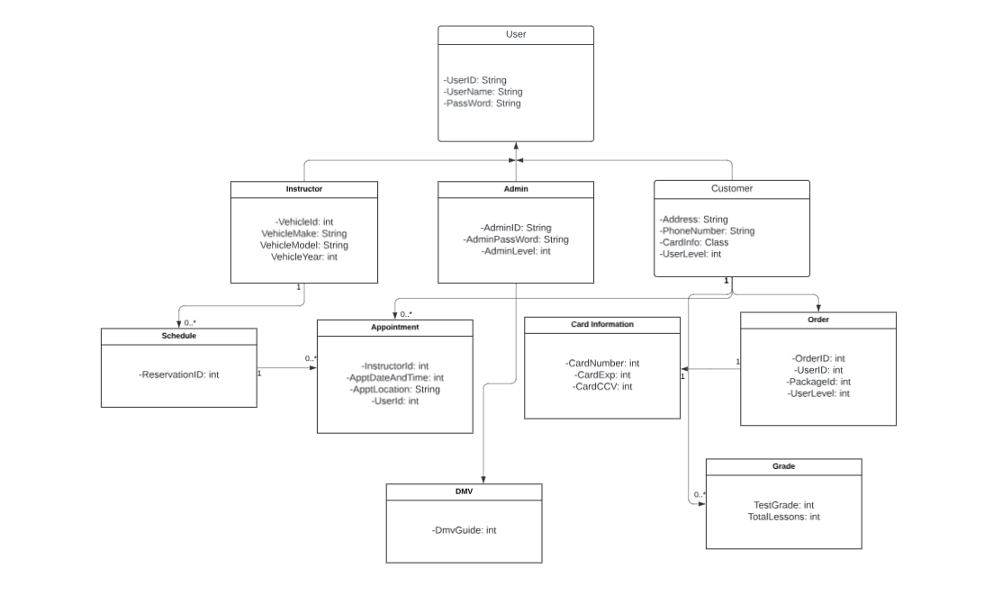

## **Technical Requirements**

* ***Computer*** *(Laptop, Monitor, Keyboard, Mouse, Speakers)*
* *Internet (Router, Ethernet Cables, Wi-Fi)*
* *Web browsers (Edge, Firefox, Chrome, Safari, Google)*
* *Security Database (SSL/TLS, CA, Data Encryption, Firewalls)*
* *Operating Systems (Windows, MAC, Linux)*
* *Storage (Saving tests, grades, DMV info)*
* *Internet Provider (Comcast, Verizon, etc.)*
* *DriverPass Software/Website access*